Mock Test 2

- Find the area of the shaded part if the side length of the square is 2 cm.
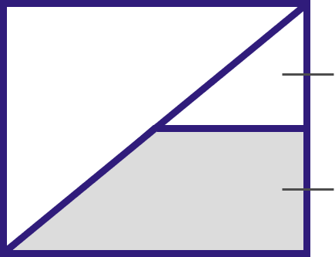
A) 3 cm²
B) 2.5 cm²
C) 1.5 cm²
D) 3.5 cm²
Difficulty level: M
Lesson: Shaded Areas
- Find the area of the shaded region.
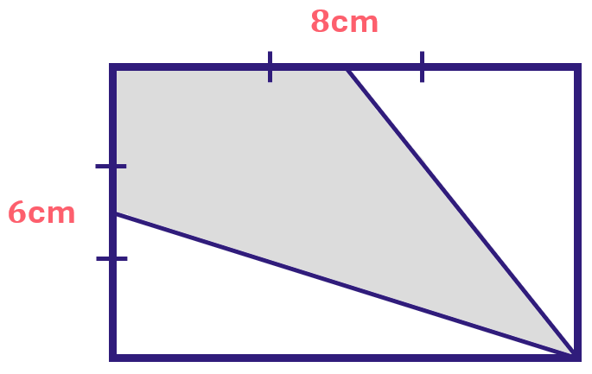
A) 20 cm²
B) 24 cm²
C) 36 cm²
D) 48 cm²
Difficulty level: M
Lesson: Shaded Areas
- ${{(3}^{7})}^{2}÷3^{5}= ?$
A) $3^{5}$
B) $3^{9}$
C) $3^{12}$
D) $3^{3}$
Difficulty level: M
Lesson: Exponents
- Evaluate: $\sqrt{\sqrt{81×81×81×81}}$
A) $3^{4}$
B) $9^{4}$
C) $3^{3}$
D) $3^{6}$
Difficulty level: M
Lesson: Exponents
- Which of the following is larger?
A | B
$$(2.5)^{2}$$ | $$6.5$$
A) A
B) B
C) Equal
D) Not enough info
Difficulty level: L
Lesson: Exponents
- Find the area of the shaded triangle.
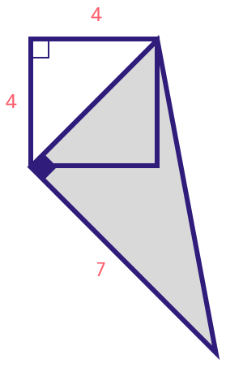
A) $14\sqrt{2}$
B) $10\sqrt{2}$
C) $7\sqrt{2}$
D) $12$
Difficulty level: H
Lesson: Triangles
- What is the minimum number of sections that can be created using four lines that pass through the center of the circle?
A) 6
B) 4
C) 8
D) 12
Difficulty level: H
Lesson: Circles
- If $C$ is a midpoint of $AB$, find the area of the circle $M.$
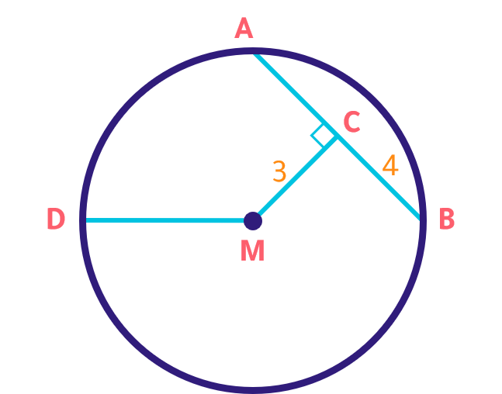
A) $9π$
B) $20π$
C) $10π$
D) $25π$
Difficulty level: H
Lesson: Circles
- If $x$ is even and $y$ is odd, which of the following should be odd?
A) $2x+2y$
B) $x+y$
C) $x+4y$
D) $x⋅y$
Difficulty level: M
Lesson: Numbers & Order of Operations
- $x+y=7 and x$ and $y$ are positive integers. Which of the following could be true?
A) $x=2$
B) $x=8$
C) $y=10$
D) $y=9$
Difficulty level: L
Lesson: Numbers & Order of Operations
- How many numbers from 1 to 40 contain the digit 2, the digit 3, or both?
A) 20
B) 24
C) 23
D) 28
Difficulty level: M
Lesson: Numbers & Order of Operations
- A man has 120 banknotes of 5 and 10 SR, and the number of 10 SR banknotes is five times the number of 5 SR banknotes. What is the total amount of money?
A) 1300
B) 1100
C) 1200
D) 1000
Difficulty level: M
Lesson: Numbers & Order of Operations
- Which of the following is a prime number?
A) 44
B) 53
C) 27
D) 81
Difficulty level: L
Lesson: Numbers & Order of Operations
- If the perimeter of the square is 64 cm, what is the area of a small rectangle?
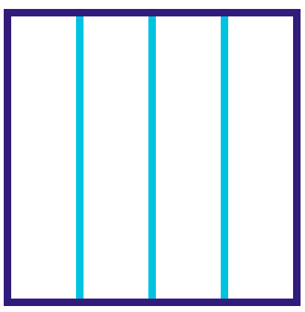
A) 32 cm²
B) 128 cm²
C) 48 cm²
D) 64 cm²
Difficulty level: M
Lesson: Areas, Perimeters & Volumes
- In the opposite figure, the sides are $x, x+2,$ and $x+3$. If the volume is $90 {cm}^{3}$, find x.
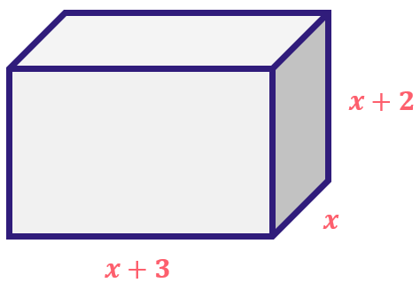
A) 2
B) 3
C) 4
D) 5
Difficulty level: H
Lesson: Areas, Perimeters & Volumes
- Solve approximately: $\frac{109.8×9.8}{4.01}$
A) 255
B) 275
C) 244
D) 270
Difficulty level: M
Lesson: Decimals
- Find the value of x in the following shape.
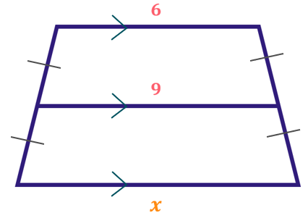
A) 15
B) 10
C) 12
D) 13
Difficulty level: M
Lesson: Polygons & Quadrilaterals
- If $70\%$of A is$350$ and $20\%$ of B is$200$, compare:
A | B
A | B
A) A is greater
B) B is greater
C) Equal
D) Not enough information
Difficulty level: M
Lesson: Ratios & Percentages
- If the number of males is $4×{10}^{6}$, and the number of females is $8×{10}^{6}$. Find the ratio between males and females
A) $\frac{1}{4}$
B) $\frac{1}{2}$
C) $\frac{3}{4}$
D) $\frac{2}{3}$
Difficulty level: L
Lesson: Ratios & Percentages
- Convert $0.25\%$ to decimal.
A) 0.00025
B) 0.25
C) 0.025
D) 0.0025
Difficulty level: L
Lesson: Ratios & Percentages
- If it costs 300 SR to ship 6 batteries, how much does it cost to ship 10 batteries?
A) 450
B) 500
C) 600
D) 400
Difficulty level: L
Lesson: Proportions
- Find $x$.
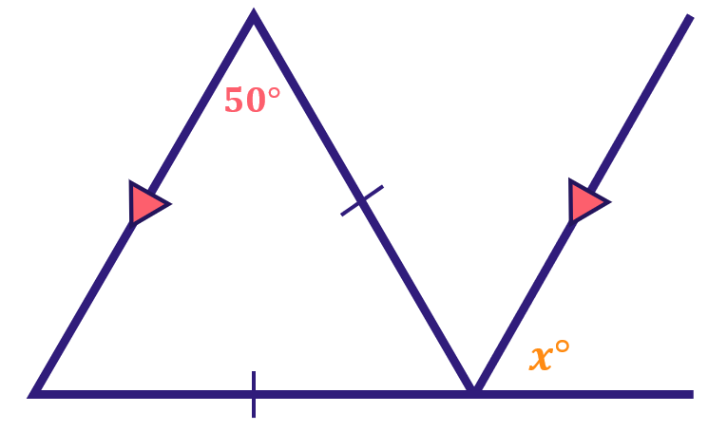
A) 70
B) 45
C) 50
D) 80
Difficulty level: M
Lesson: Angles
- What is the measure of the angle created if the earth rotated for 4 hours?
A) $\frac{π}{4}$
B) $\frac{π}{6}$
C) $\frac{π}{3}$
D) $\frac{π}{10}$
Difficulty level: M
Lesson: Angles
- If $x>0$, compare:
A | B
$$\frac{1}{x}$$ | $$x^{2}$$
A) A is greater
B) B is greater
C) Equal
D) Not enough info
Difficulty level: M
Lesson: Algebraic Expressions, Equations & Inequalities
- If $y^{2}=\frac{1}{25}$, compare:
A | B
$$y$$ | $$-\frac{1}{5}$$
A) A is greater
B) B is greater
C) Equal
D) Not enough info
Difficulty level: M
Lesson: Algebraic Expressions, Equations & Inequalities
- Find the sum of roots for $x^{2}-1=0$
A) 3
B) 2
C) 1
D) 0
Difficulty level: M
Lesson: Algebraic Expressions, Equations & Inequalities
- Simplify: $\frac{1}{2x+4}+\frac{1}{2x}$
A) $\frac{1}{2+4x}$
B) $x^{2}+4x$
C) $\frac{x+1}{x^{2}+2x}$
D) $\frac{4x+4}{2x^{2}+4x}$
Difficulty level: H
Lesson: Algebraic Expressions, Equations & Inequalities
- If $3|x|=15$, compare:
A | B
$$x$$ | $$5$$
A) A is greater
B) B is greater
C) Equal
D) Not enough info
Difficulty level: L
Lesson: Algebraic Expressions, Equations & Inequalities
- If $2x=5y$, compare:
A | B
$$x$$ | $$y$$
A) A is greater
B) B is greater
C) Equal
D) Not enough info
Difficulty level: H
Lesson: Algebraic Expressions, Equations & Inequalities
- The graph shows the sales of a clothing store. In which month were women’s clothing sales the lowest?
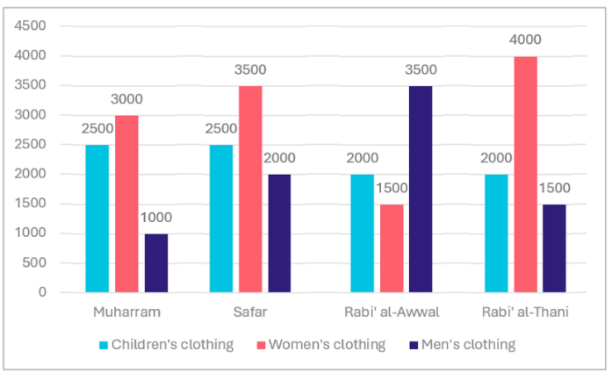
A) Rabi’ al-Thani
B) Rabi’ al-Awwal
C) Safar
D) Muharram
Difficulty level: L
Lesson: Data Analysis
- There are 300 students represented in the opposite shape. How many students passed the exam?
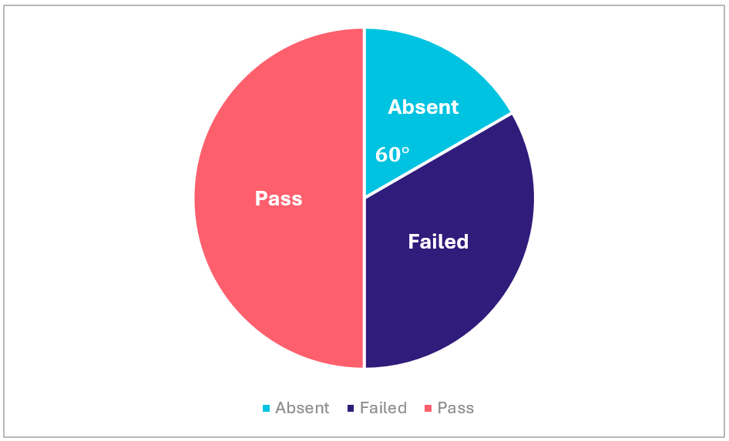
A) $100$
B) 80
C) 120
D) $150$
Difficulty level: L
Lesson: Data Analysis
- Based on the figure below, what was the highest percentage increase in silk sales from one month to the next?
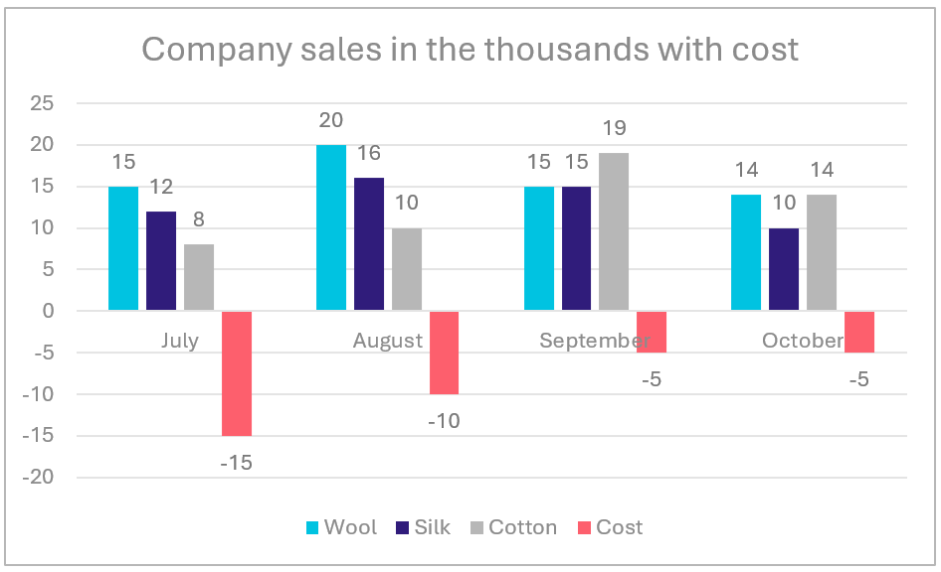
A) $50\%$
B) $33.33\%$
C) $25\%$
D) $66.67\%$
Difficulty level: M
Lesson: Data Analysis
- The graph shows the percentages of cars made in different countries. What is the percentage of cars made in the USA?
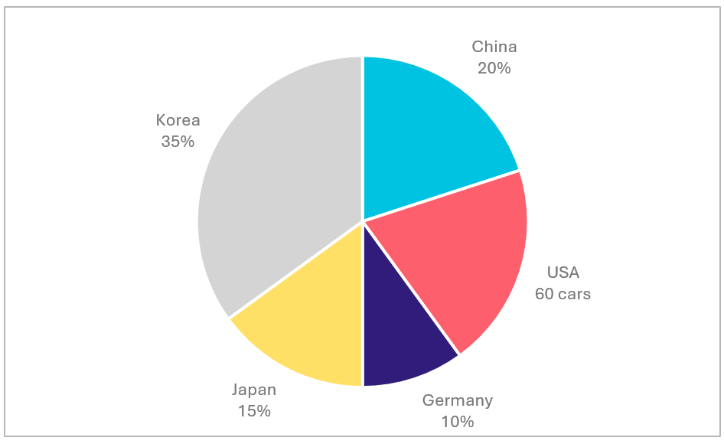
A) $15\%$
B) $10\%$
C) $20\%$
D) $25\%$
Difficulty level: L
Lesson: Data Analysis
- The table shows data of different schools. How many non-Saudi teachers are there in total?
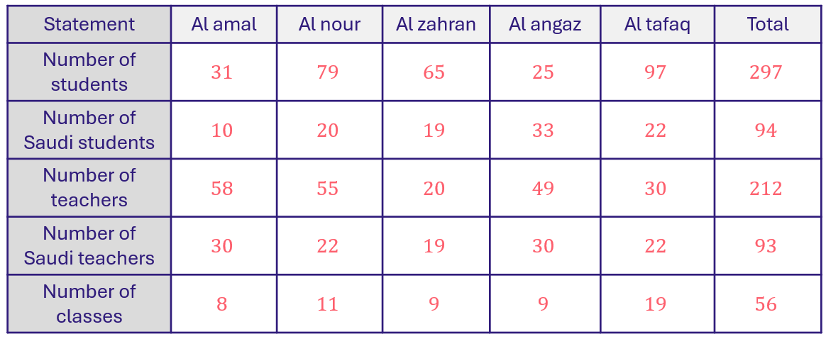
A) 45
B) 119
C) 145
D) 400
Difficulty level: M
Lesson: Data Analysis
- Calculate: $\frac{1}{\frac{1}{3}}+\frac{2}{\frac{2}{6}}+\frac{7}{\frac{7}{3}}$
A) 10
B) 12
C) 21
D) 8
Difficulty level: H
Lesson: Fractions
- If $x=14$ and $y=15$, what is the value of $\frac{1}{35}×x×y$?
A) 10
B) 5
C) 6
D) 9
Difficulty level: L
Lesson: Fractions
- If 49 notebooks are distributed equally among 9 students, how many notebooks will be left undistributed??
A) 3
B) 5
C) 6
D) 4
Difficulty level: L
Lesson: Division
- Compare:
A | B
$$\sqrt{44+33}$$ | $$9$$
A) A is greater
B) B is greater
C) Equal
D) Not enough info
Difficulty level: L
Lesson: Roots
- Find the mean of the values for all colors in 2017.
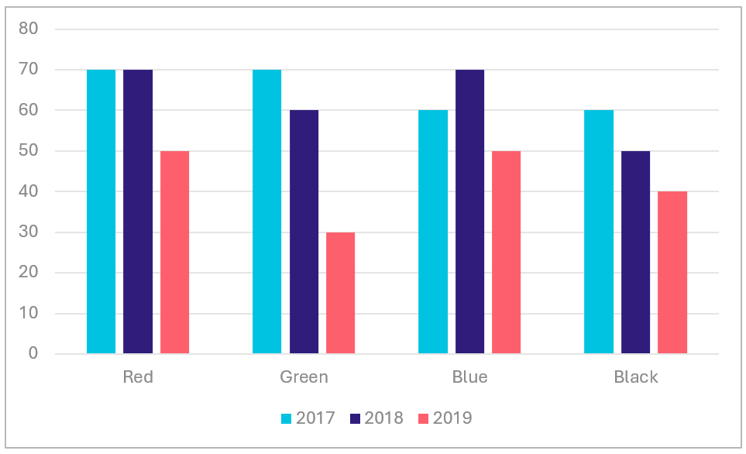
A) 70
B) 65
C) 45
D) 80
Difficulty level: L
Lesson: Statistics
- Sarah owes her friend 12 SAR. She then receives 15 SAR from a relative. After spending 3 SAR on a gift and returning what she owes to her friend, how much money does Sarah have now?
A) 0 SAR
B) 3 SAR
C) 12 SAR
D) 14 SAR
Difficulty level: L
Lesson: Numbers & Order of Operations
- $1^{5678421}+1^{1000}=?$
A) 2
B) 5
C) 7
D) 9
Difficulty level: M
Lesson: Exponents
- What will be the maximum area of the circle if it is inscribed in a square of base length 16?
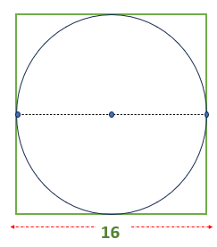
A) $24π$
B) $35π$
C) $64π$
D) $77π$
Difficulty level: L
Lesson: Circles
- A number multiplied by 15 gives the number 810, what is that number?
A) 50
B) 54
C) 234
D) 199
Difficulty level: L
Lesson: Division
- If $2x+2=-x+2$, find the value of x.
A) 1
B) 4
C) 0
D) 7
Difficulty level: L
Lesson: Equations & Inequalities
- Find the value of $(x)$:
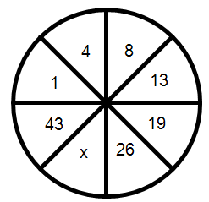
A) 34
B) 35
C) 40
D) 18
Difficulty level: L
Lesson: Sequences & Patterns
- If $X+Y=\frac{z}{2} , X-Y=0$, which of the following is correct?
A) $Z=2XY$
B) $Y=2Z-4Y$
C) $2X=2Z$
D) $2X=Z-2Y$
Difficulty level: L
Lesson: Algebraic Expressions
- Two even numbers, the difference equals 10, and their sum is equal to 74. Which is the smaller number?
A) 26
B) 28
C) 30
D) 32
Difficulty level: L
Lesson: Equations & Inequalities
- If $9x=27$, what's the value of $x$?
A) 4
B) 7
C) 6
D) 3
Difficulty level: L
Lesson: Equations & Inequalities
- Find the value of $\frac{{10}^{-5}}{{10}^{-2}}$.
A) ${10}^{-3}$
B) ${10}^{-4}$
C) ${10}^{-5}$
D) ${10}^{-7}$
Difficulty level: L
Lesson: Exponents
- If $x^{2}-y^{2}=24, x+y=6$, find $x-y$.
A) 8
B) 20
C) 12
D) 4
Difficulty level: L
Lesson: Equations & Inequalities

Mock Test 2 - Answer Key

Q# | Answer | Q# | Answer
1 | C | 26 | D
2 | B | 27 | C
3 | B | 28 | D
4 | A | 29 | D
5 | B | 30 | B
6 | A | 31 | D
7 | C | 32 | B
8 | D | 33 | C
9 | B | 34 | B
10 | A | 35 | B
11 | B | 36 | C
12 | B | 37 | D
13 | B | 38 | B
14 | D | 39 | B
15 | B | 40 | A
16 | D | 41 | A
17 | C | 42 | C
18 | B | 43 | B
19 | B | 44 | C
20 | D | 45 | A
21 | B | 46 | D
22 | C | 47 | D
23 | C | 48 | D
24 | D | 49 | A
25 | D | 50 | D

